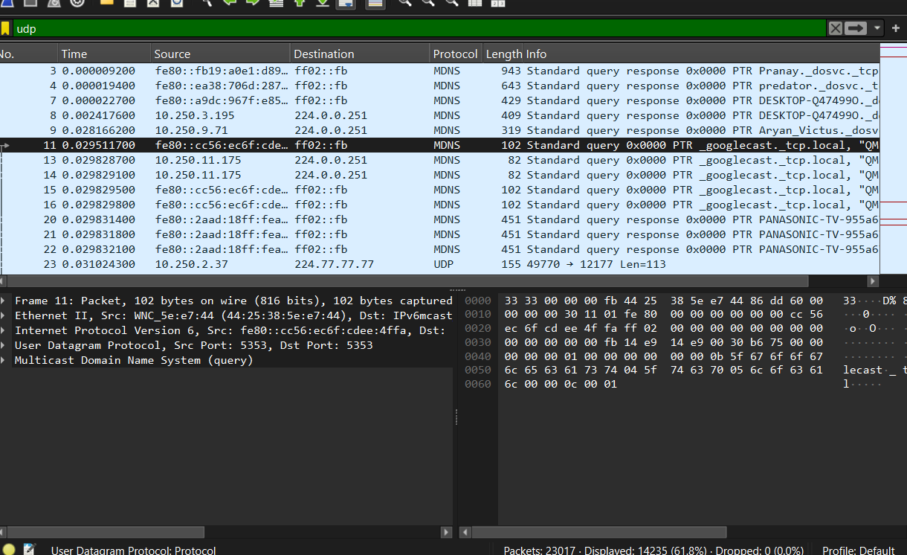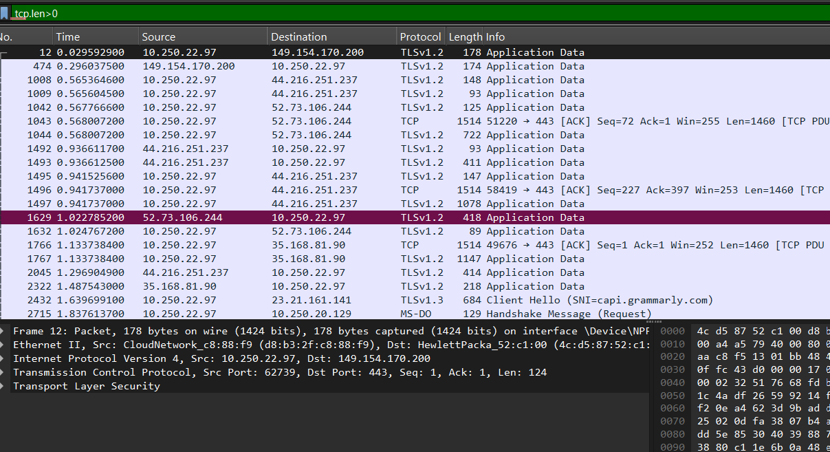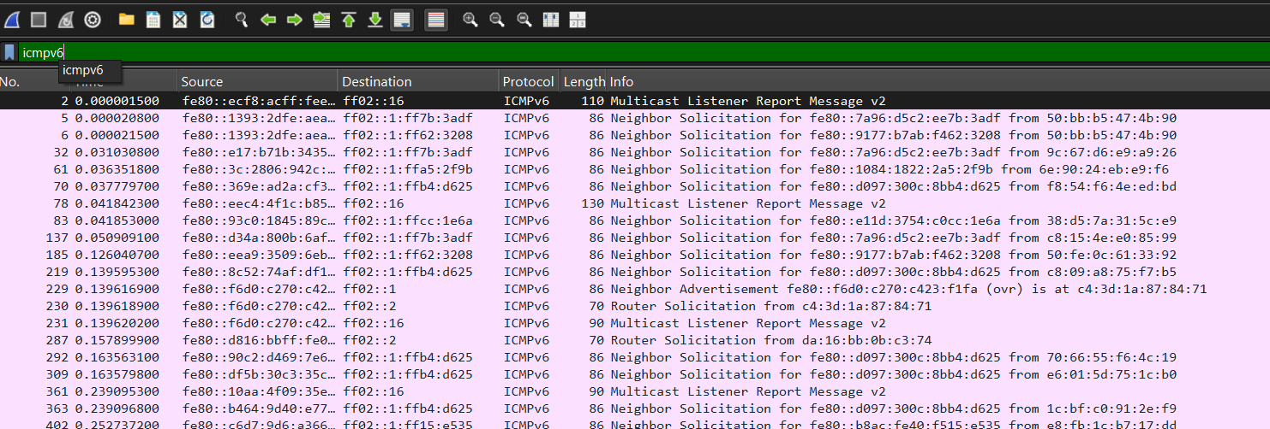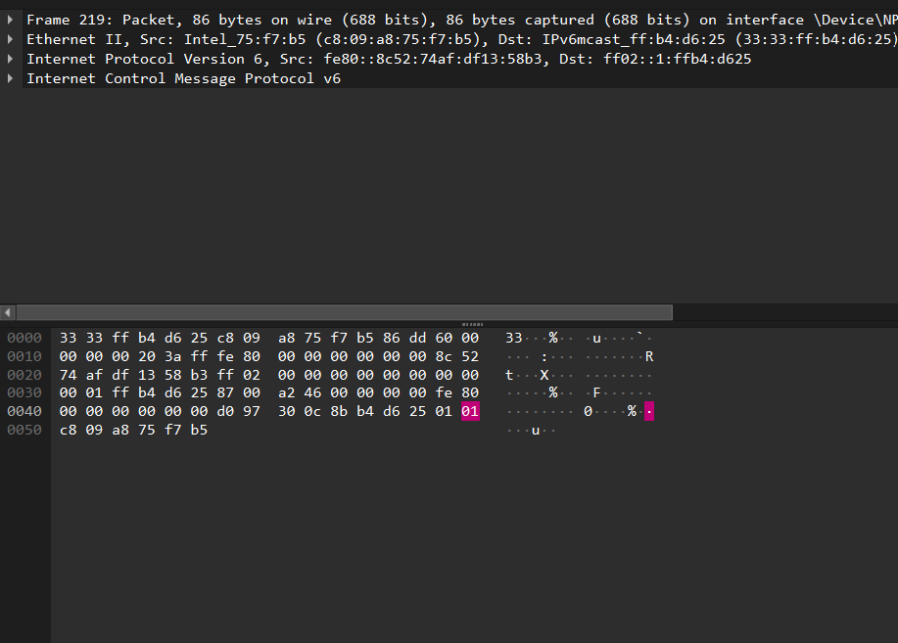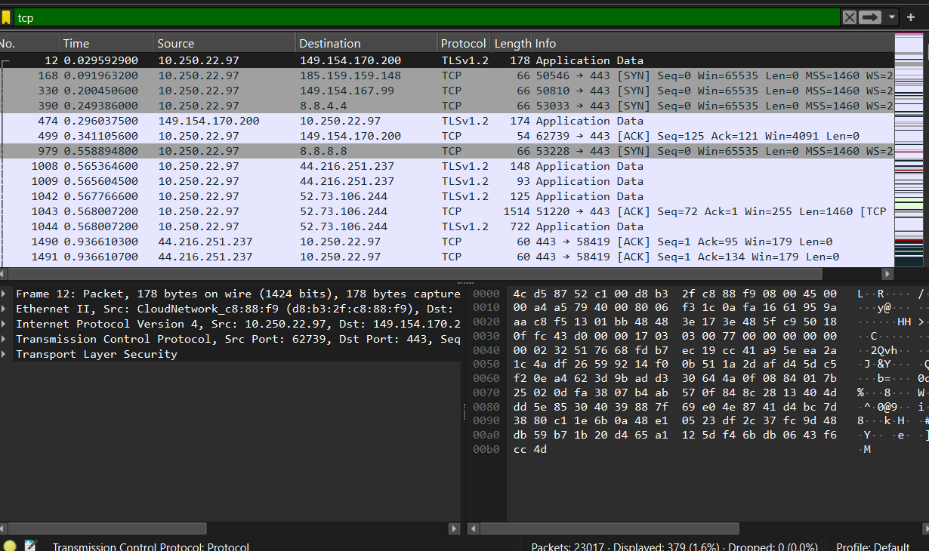
2520030416 – keerthi g
Cnnp skill 1

Step 7: Fill in your observation table
Record values from your own Wireshark capture.
parameters | TCP packet | UDP packet
Frame length | 66 bytes | 419 bytes
Ethernet header length | 14 bytes | 14 bytes
IP header Length | 20 bytes | 20 bytes
Transport header length | 32 bytes | -
IP total length | 52 bytes | 405
Transport header length | 32 bytes | -
Payload length | 32 bytes | 385

